Site Design

Intentions/Goals:

Create a basic but functional website that fulfills all curricular and personal requirements.

Curricular Requirements:

* Navigation Bar
* Embedded Images
* CSS (In-line and otherwise)
* Resume page built using tables
* Interests page with images and hyperlinks
* Guestbook page with mailto: form
* Reflections page
* W3C compliant
* Appropriate file structure

Personal Requirements:

* Simple rounded aesthetic
* Color pallet restricted to three colors
* Usability as high priority
* Use methods and techniques from outside sources if time permits
* Philosophically appealing
* Visually appealing
* Relatively mobile friendly
* Make majority of elements scalable at lower resolutions for non-mobile environments

Philosophy:

The philosophy behind many if not all my designs are two things (well technically three): Simplicity with depth and finding the balance between them. The name “Information Curiosity” is exactly that. It provides the user with, on one side, surface-layer information about myself, my interests, and my thoughts. While on the Curiosity side there is a resume, not exactly need-to-know information in my opinion but there is your curiosity is peaked. The guestbook page fits this side because I am curious about you, the user of this website. The credits page, while it wasn’t a curricular requirement, was added for a couple of reasons. Firstly, I wanted to in a way give back to all the helpful places, people, and tools I had used to make this project. Secondly, I needed something to balance the menu space since the curricular requirements were an odd number.

Process:

Planning began with iterating on visual design and general aesthetic. Using many of the tutorials from W3schools.com and the lessons taught in the CS241, a combination of: HTML, CSS, JavaScript, and jQuery, I was able to do this project with relatively little difficulty. The following images are the iteration at varying stages over the course of a roughly three-week time frame, starting with pencil sketches, prototype designs made in Adobe XD, and finally an HTML based version with CSS elements.

In the current state Version 5 of the website I have accomplished all intentions and goals, both curricular and personal. Currently, I consider the project complete and satisfactory.

*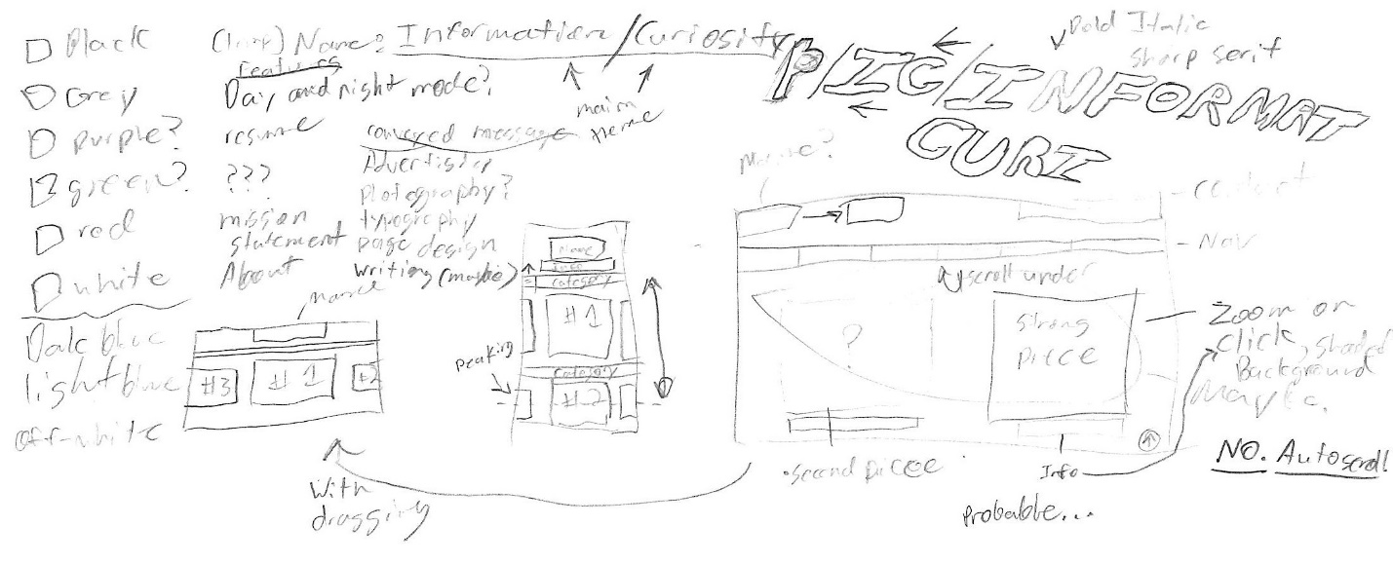*

*Primary page sketches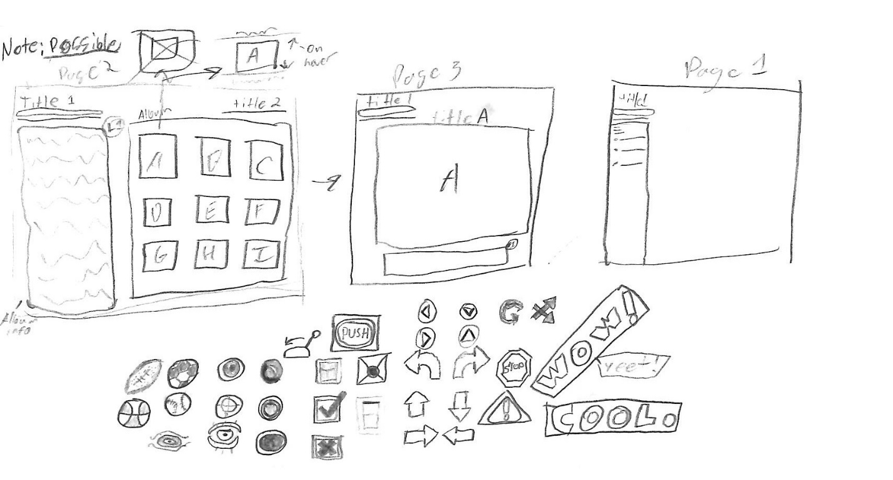*

*Secondary page sketches with possible icon designs.*

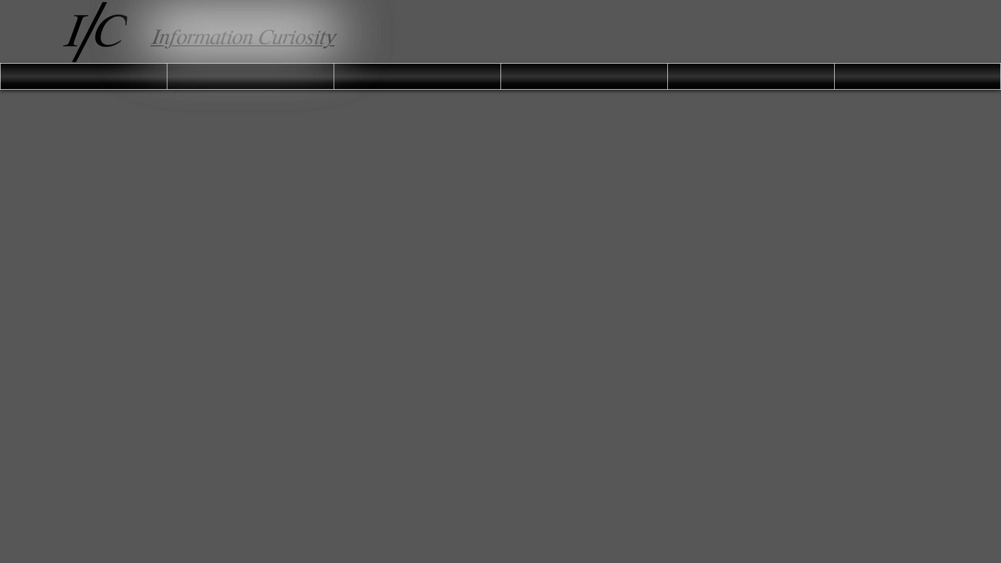

*Version 1: Site name “Information Curiosity” is established coupled*

*with basic idea for navigation bar.*

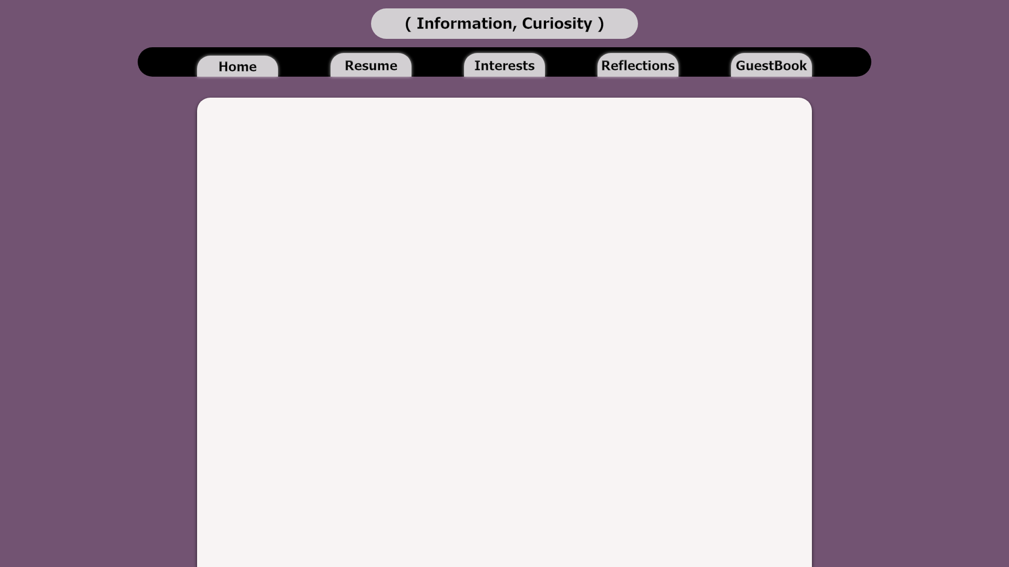

*Version 2: Navigation bar V1 and primary logo design iteration V1.*

*Basic Color and UI theme established.*

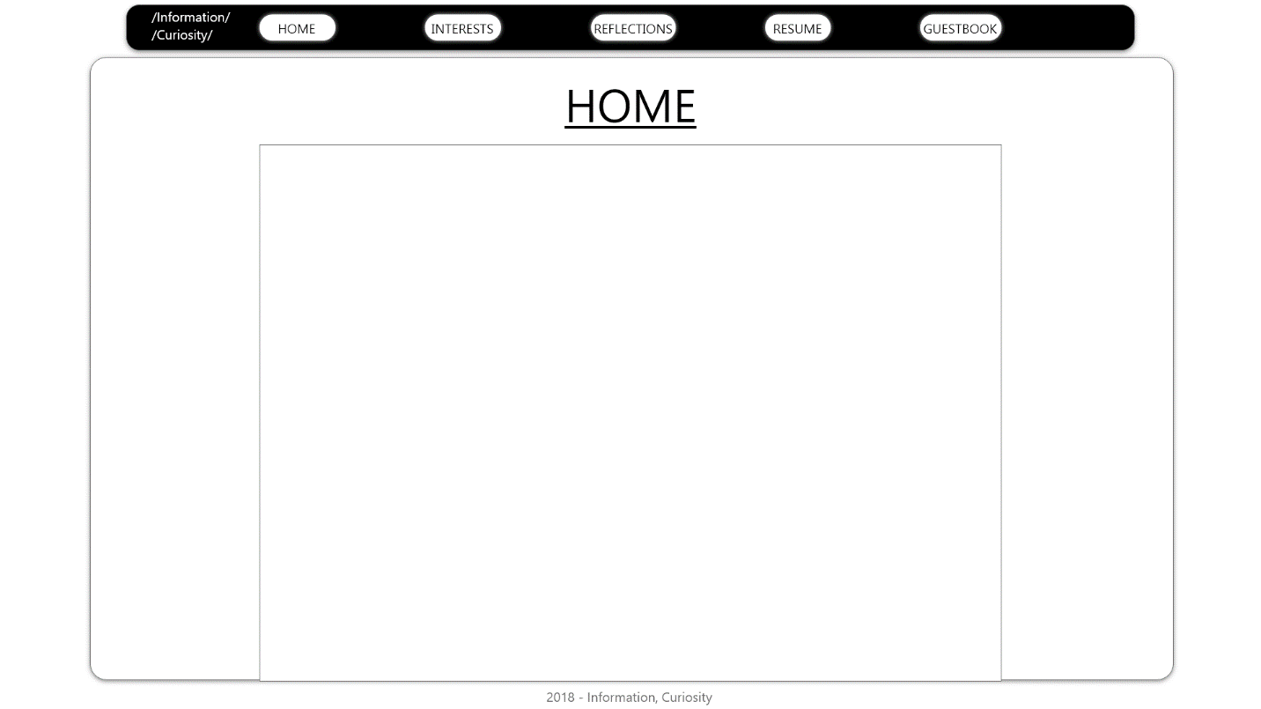

*Version 3: Possible reiteration of basic theme and design.*

*Navigation bar design kept, while visual theme was dropped.*

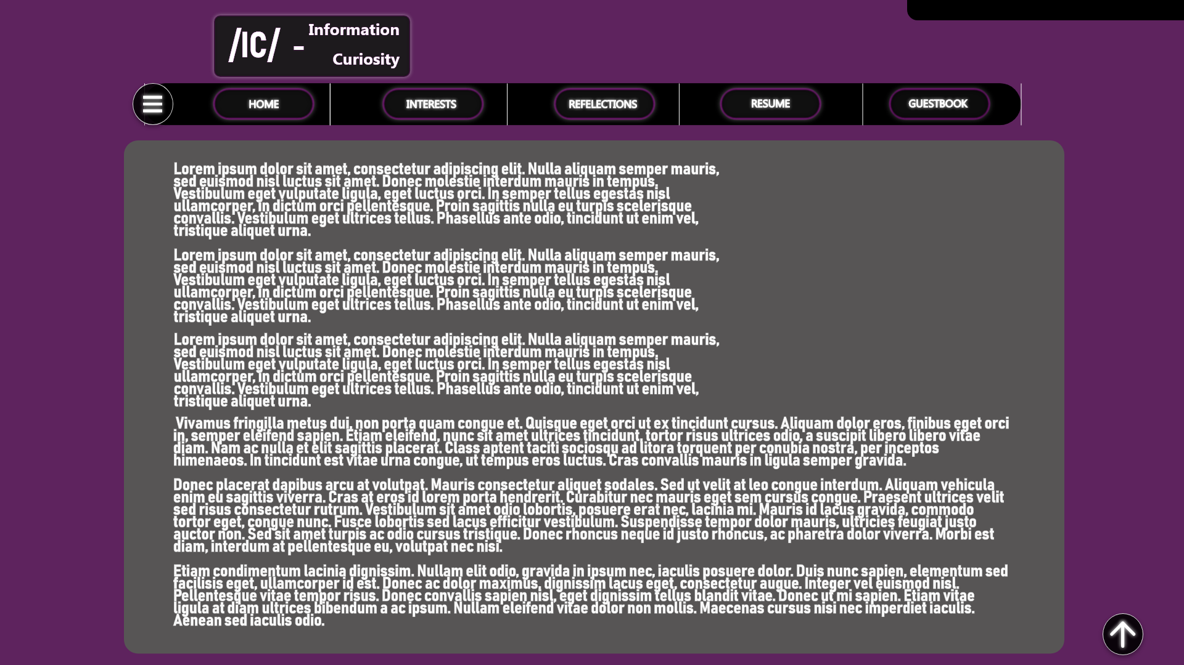

*Version 4: Latest version prior to HTML iteration.*

Current State:

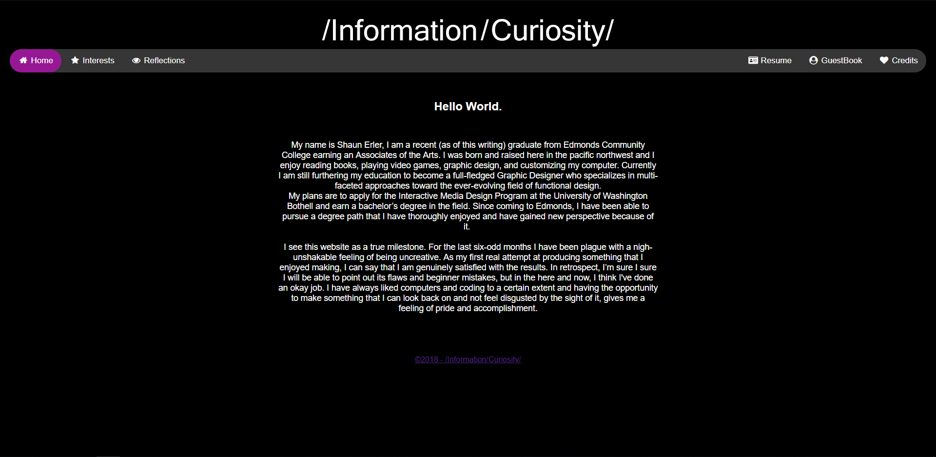

*Version 5: Home Page*

Menu bar built using the following tutorial: <https://www.w3schools.com/howto/howto_css_navbar_icon.asp>

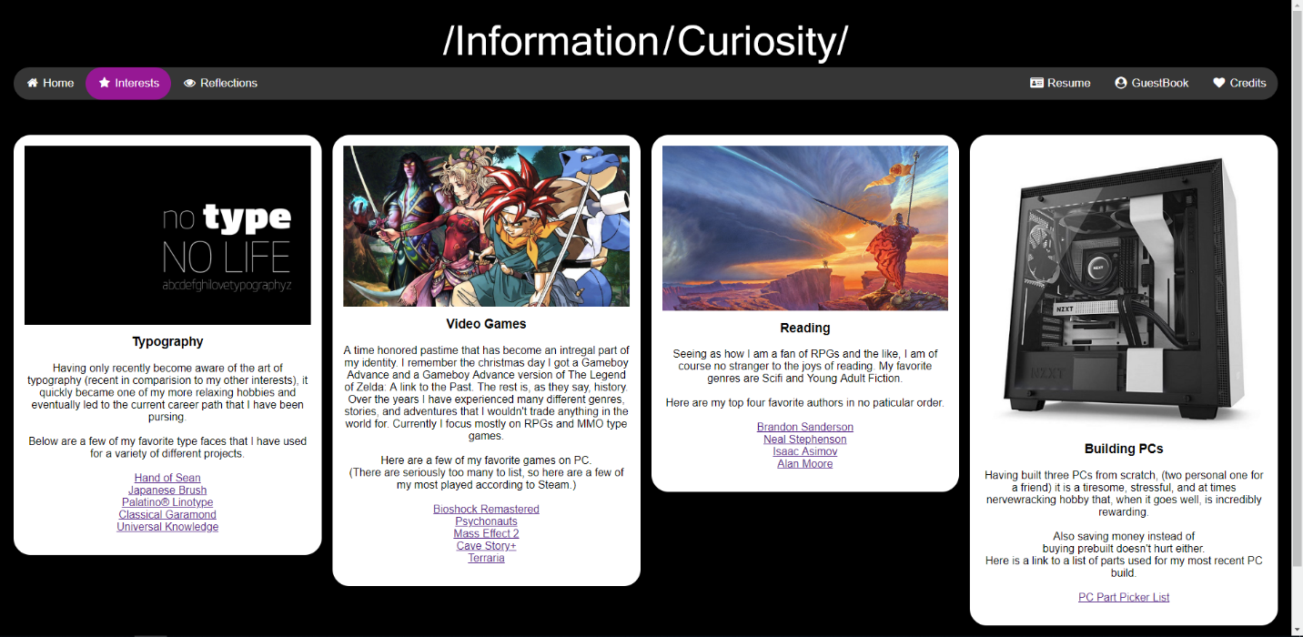

*Version 5: Interests Page*

Modal Image gallery built using the following tutorial:

<https://www.w3schools.com/howto/howto_js_lightbox.asp>

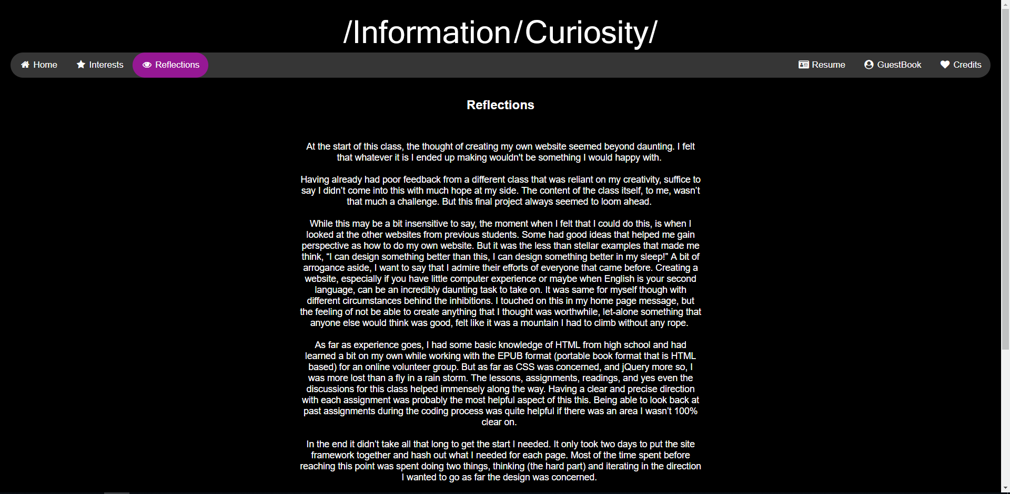

*Version 5: Reflections Page*

Sliding animation was made from the following repurposed resource:

<https://ianlunn.co.uk/portfolio/hover-css/>

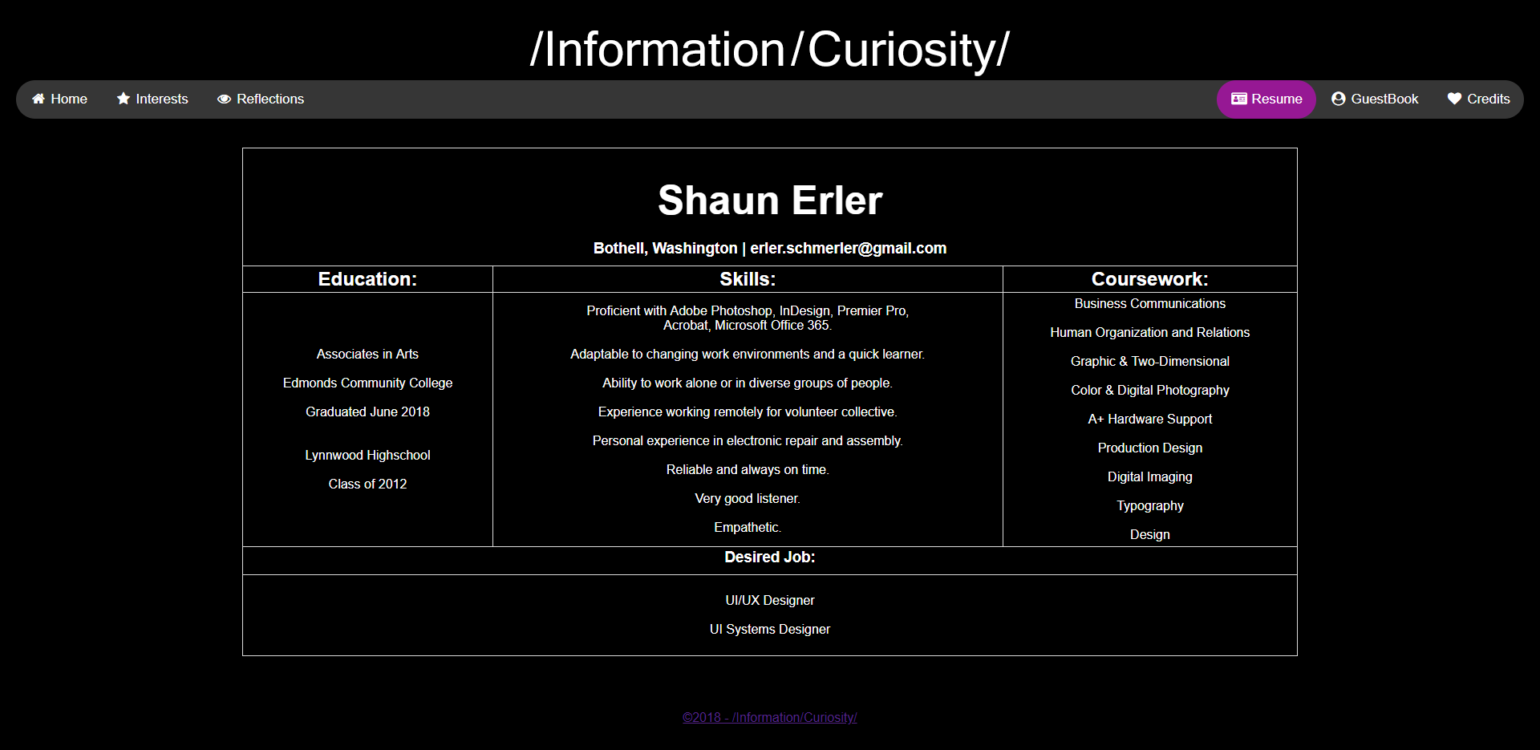

*Version 5: Resume Page*

Resume Page built in conjunction from the following tutorial and class assignment:

<https://www.w3schools.com/css/css_table.asp>

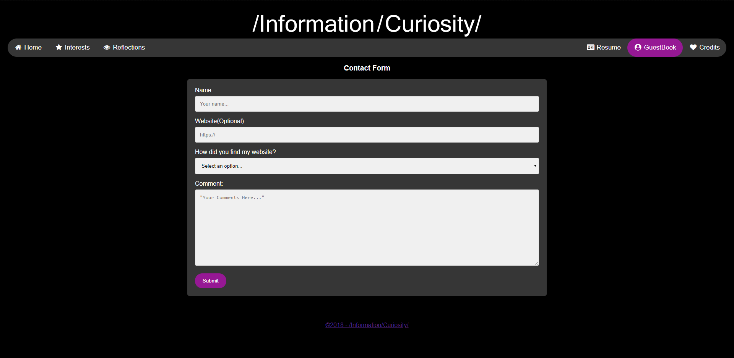

*Version 5: Guestbook Page*

Contact Form built in conjunction from the following tutorial and class assignment:

<https://www.w3schools.com/howto/howto_css_contact_form.asp>

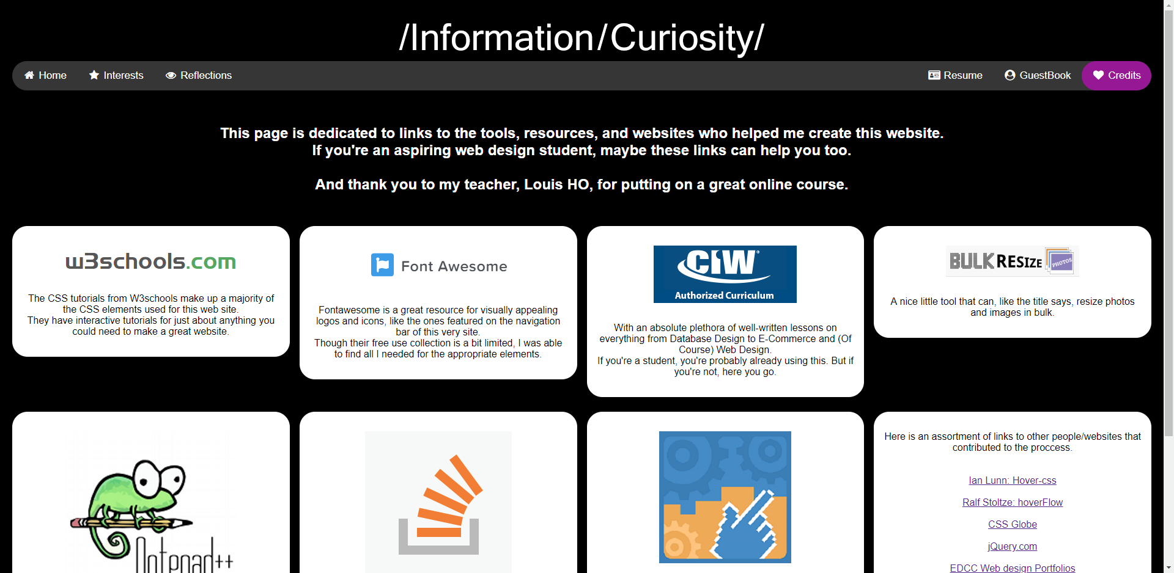

*Version 5: Credits Page*

Repurposed Modal Gallery, minus the lightbox element.

Images now link to their respective sources.

Challenges:

The challenges faced during this project can be summed as this: non-insurmountable, but still frustrating at times. I’ve already mentioned non-ideal animation of the header logo in my reflections page, so I’ll skip that one for now. Overall formatting of text placement was probably the biggest frustration, especially if you want to center, well, *anything*. In order to center the text on the home and reflections page I had to use VERY large margin values, and if the viewing screen is anything smaller than 1440x900 resolution, then all that extra margin space squeezes together far tighter than I would have liked. Scaling has overall been an issue, ideally the modal gallery will, at a narrow/mobile resolution, shuffle the elements downward to that instead of a row of four it would turn into a two-by-two.

Another small issue is the caption text in the modal gallery. According to the tutorial I don’t have to anything special, at least from looking at their example code I don’t. While I was able to get it working with some trial and error, formatting it to be centered and italic remains incredibly troublesome.

These challenges, while not utterly website breaking, will be taken as lessons and areas to be improved upon.